Project Report

# Introduction:

The aim of this project is to create an ecommerce website using HTML, CSS, and JavaScript to dynamically display products and provide a shopping cart feature. The website consists of multiple pages, including a Home page, a Gallery page, an About Us page, a Contact Us form, and a Cart page. The main functionality of the website is to showcase products dynamically fetched and allow users to add products to their cart and checkout easily.

# Technologies Used:

1. HTML5: For creating the basic structure and content of the website.
2. CSS3: For styling the website and making it visually appealing.
3. JavaScript: To handle dynamic product display, user interactions, and cart functionality.
4. Local Storage: To store cart items and maintain cart state across different pages.

# Website Pages and Features:

## Home Page:

* + The Home page provides a brief introduction to the website.
  + It has a navigation bar with links to other pages.
  + A featured product section showcases the most popular product.
  + Each product displays its name, image, description, and price.
  + Users can add products to their cart directly from the Home page.

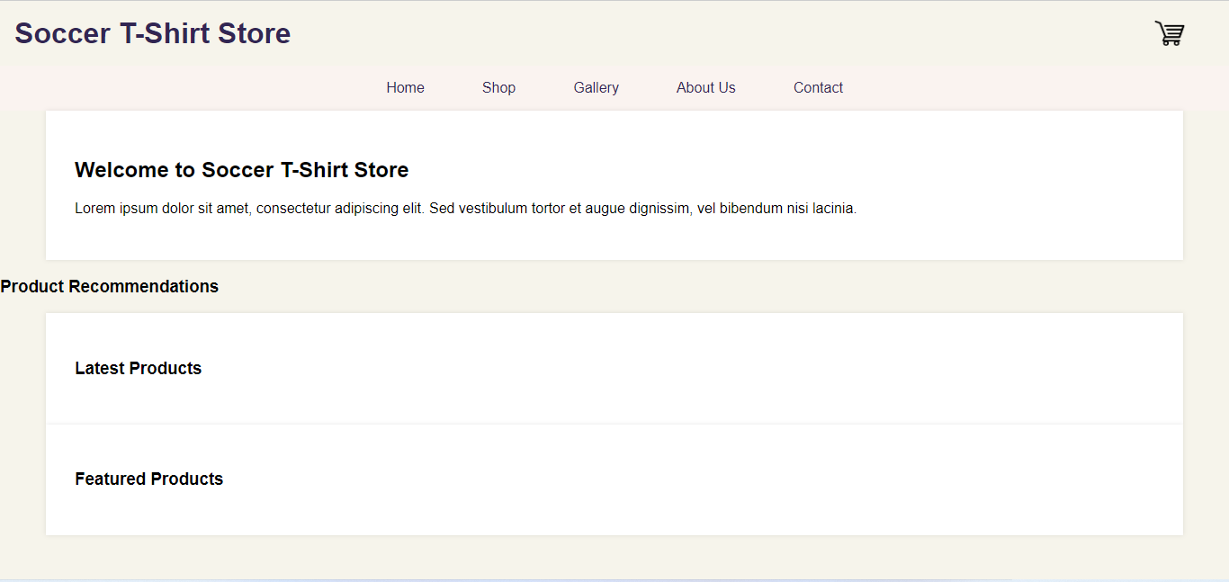

## Shop Page:

* Product Listing: Display a grid or list of products available for purchase on the shop page.
* Product Information: Show relevant information about each product, including the product name, image, description, and price.
* Add to Cart Button: Place an "Add to Cart" button alongside each product, allowing users to add items to their cart with a single click.
* Cart Icon/Counter: Display a cart icon with a visible item count near it to indicate the number of items currently added to the cart.
* Cart Update Confirmation: Provide a visual confirmation or notification when a product is successfully added to the cart, allowing users to know that the action was successful.

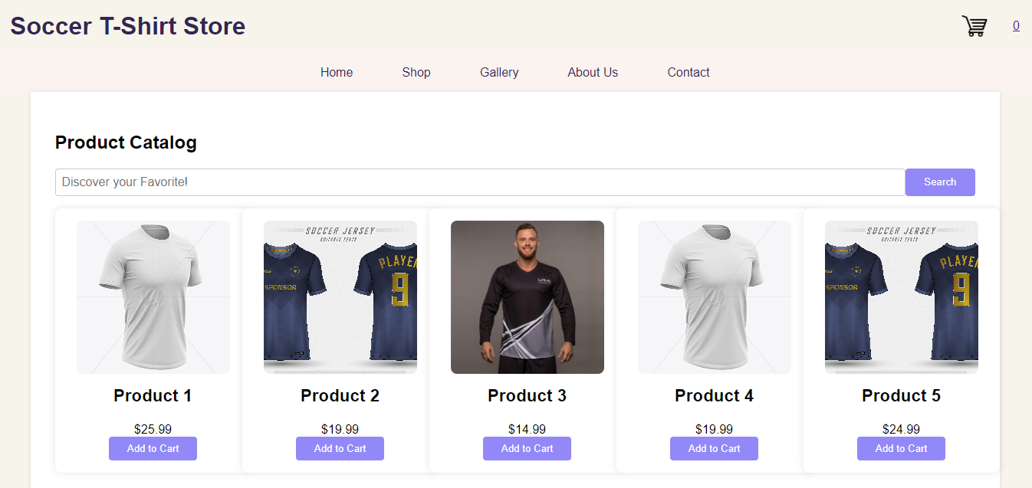

## 

## Gallery Page:

* + The Gallery page displays a grid of product images.
  + Clicking on an image opens a modal with a larger view of the product image.
  + Users can add products to their cart from the Gallery page as well.

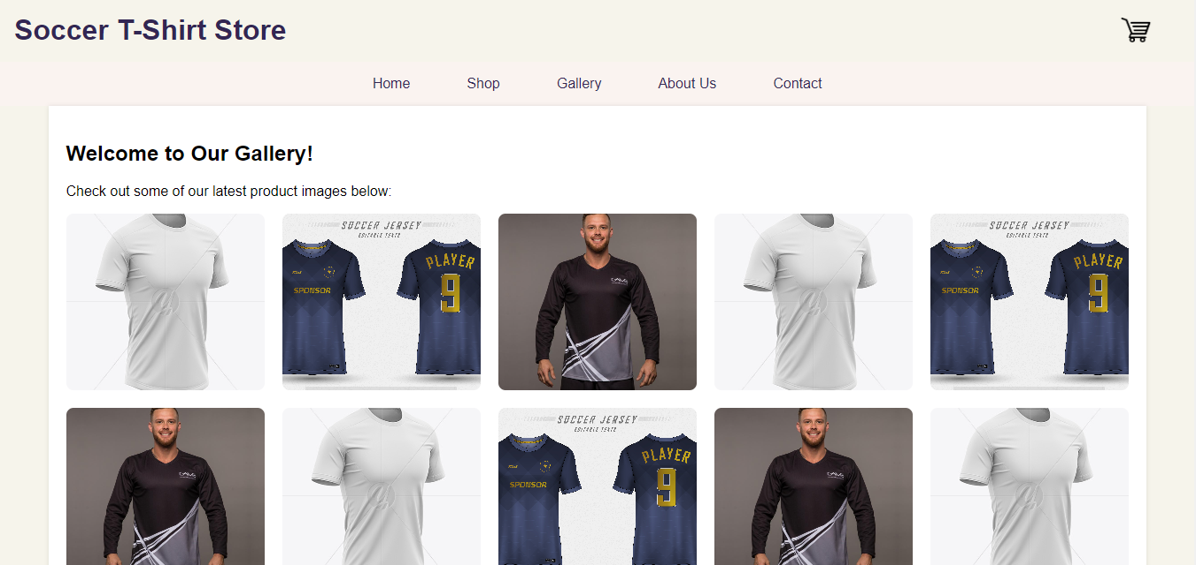

## About Us:

* + The About Us page provides information about the company or website.
  + It includes details about the team and the purpose of the website.

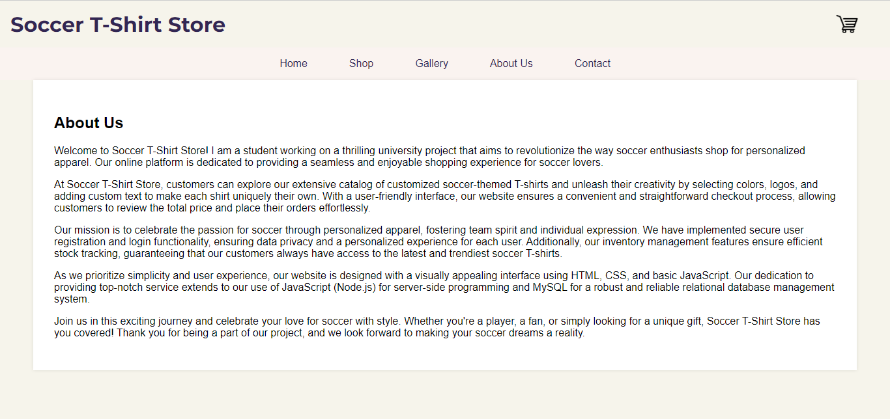

## Contact Us Form:

* + The Contact Us page has a form with fields for the user to enter their name, email, and message.
  + Upon submission, the form sends an email to the website admin with the user's inquiry.

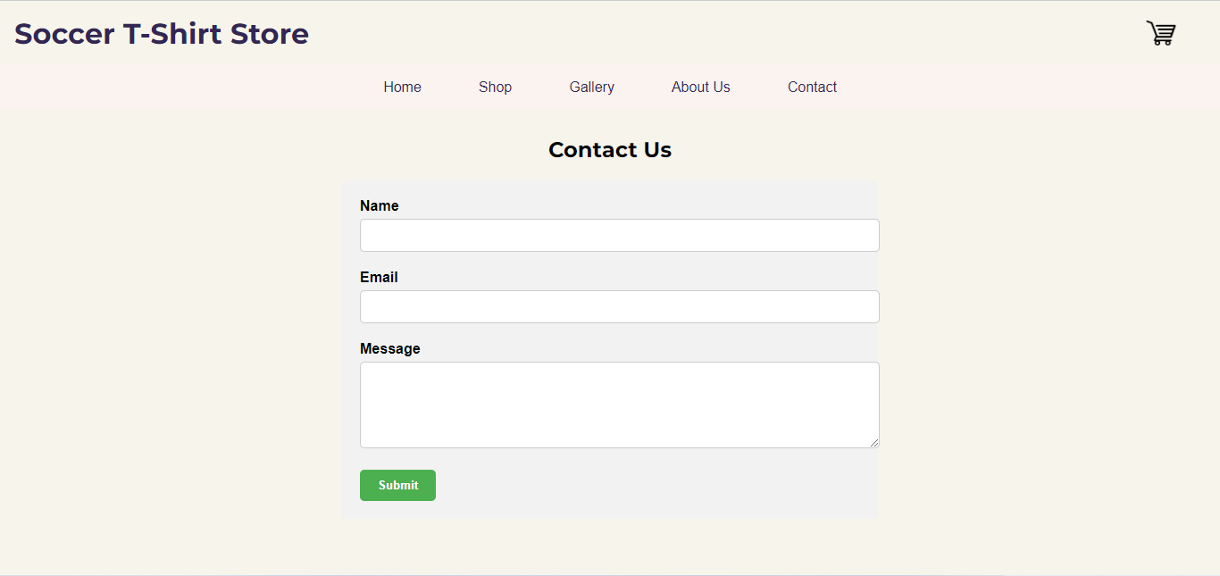

## Cart Page:

* + The Cart page displays all the products added by the user for purchase.
  + Users can see the product name, quantity, price, and total amount in the cart.
  + They can modify the quantity or remove items from the cart.
  + The cart displays the total amount to be paid by the user.

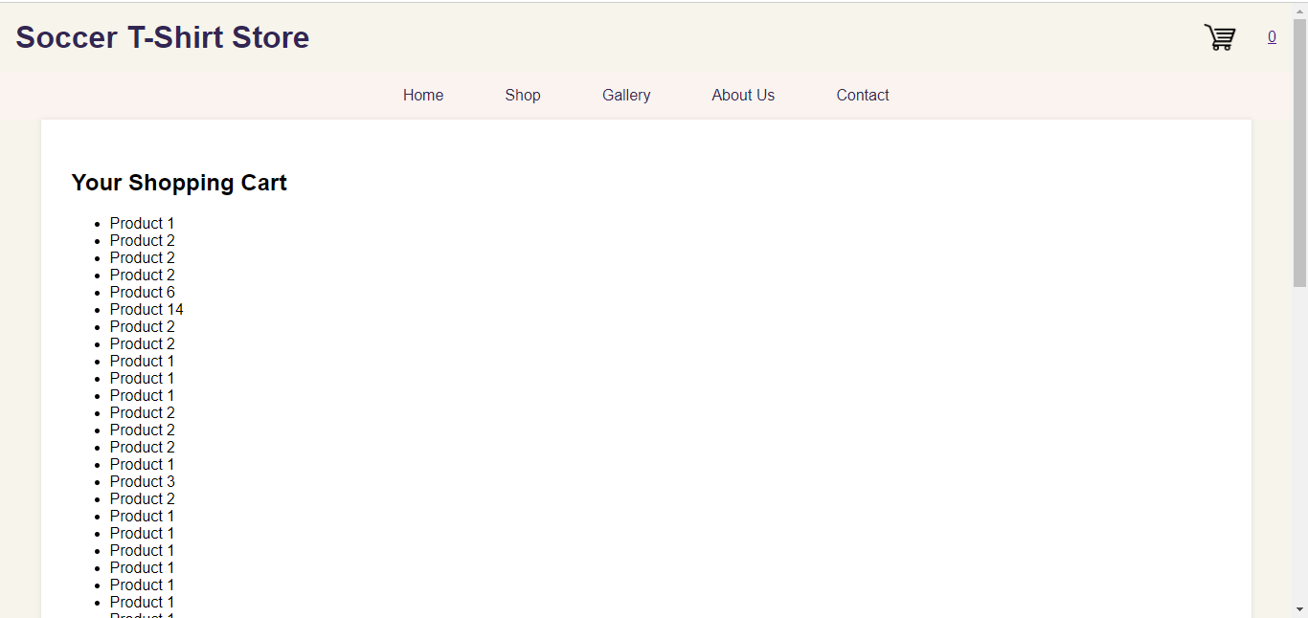

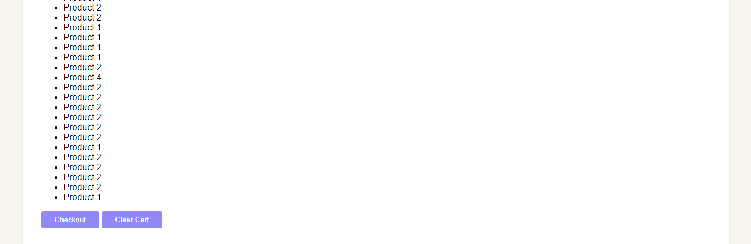

# Implementation Details:

## HTML Structure:

* + Create individual HTML files for each page: index.html, gallery.html, aboutus.html, contactus.html, and cart.html.
  + Link the CSS and JavaScript files to the HTML pages.

## CSS Styling:

* + Apply responsive design principles to ensure the website looks good on various devices.
  + Style the navigation bar, product grid, modal, contact form, and cart elements to enhance the user experience.

## JavaScript Logic:

* + Used JavaScript to fetch data and dynamically display products on the Home and Gallery pages.
  + Implemented the model functionality to show a larger view of the product image when clicked.
  + Add cart functionality, allowing users to add products to their cart and manage cart items.
  + Utilize local storage to store cart items, ensuring the cart state persists across different pages.

# Conclusion:

In conclusion, this simple website project successfully implements dynamic product display using HTML, CSS, and JavaScript, along with a shopping cart feature. The Home page, Gallery page, About Us page, Contact Us form, and Cart page enhance the user experience and provide necessary information about the website and its products. Users can conveniently browse through products, view their details, and directly add items to their cart. The cart functionality, backed by local storage, ensures that users' selected items remain in the cart even when navigating to different pages on the website. This feature adds significant value to the website, making it more practical and user-friendly for potential customers. This project lays the foundation for future enhancements and potential e-commerce capabilities that can be added to the website.